Homework 5

# Problem

*It is possible that, after the technological innovation, $\left(A,B\right)$ is no longer the minimum $\text{s-t}$ cut.*

Reference: <https://stackoverflow.com/questions/40277603/is-minimum-cut-same-for-the-graph-after-increasing-edge-capacity-by-1-for-all-ed#:~:text=Since%20c%20is%20a%20constant,N(c%2B1)%20>.

Consider the counter example below.

Before the technological innovation, we have the following network. The edge labels are capacities.

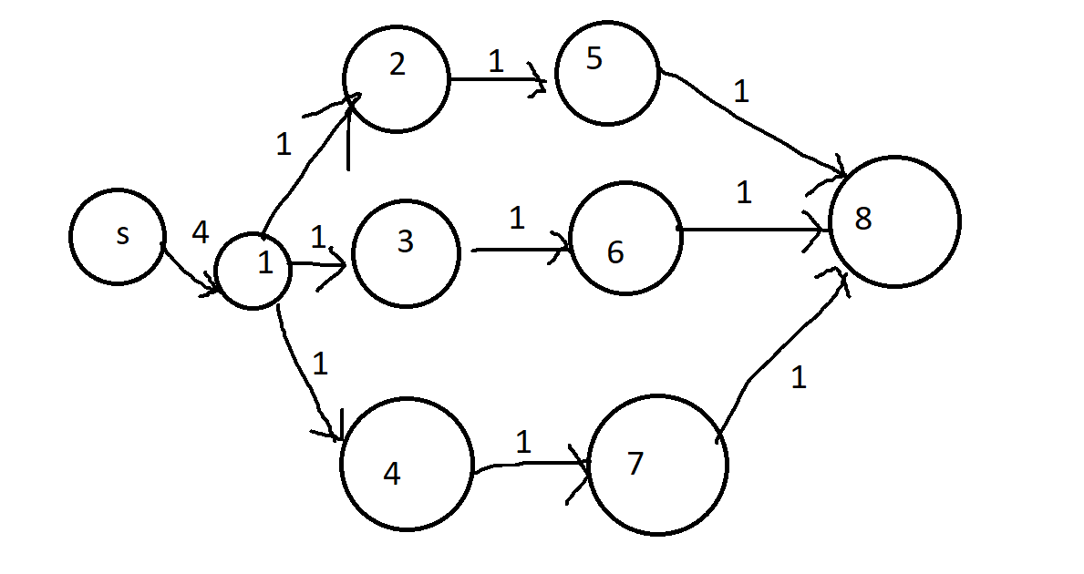

The minimum cut is shown below where $A=\left\{s,1\right\}$ and $\text{cap}\left(A,B\right)=3$

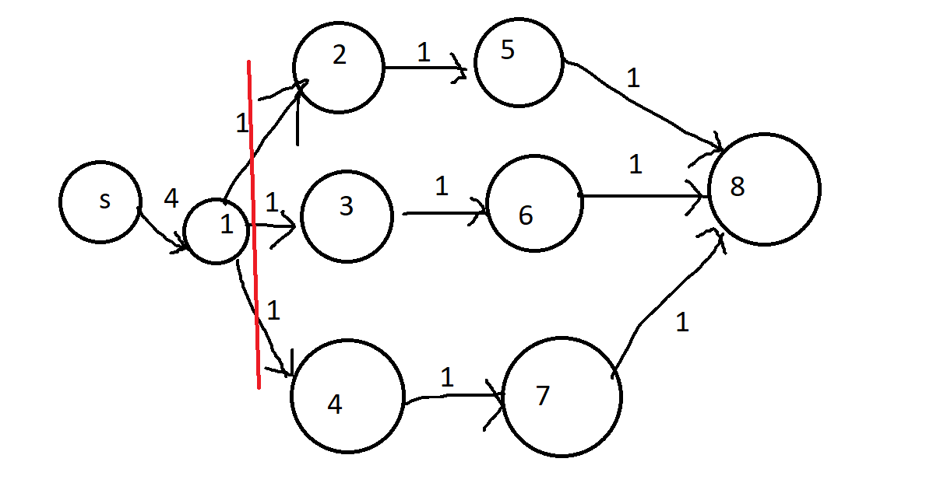

Now, consider the technologies innovation, where capacities are increased by 5, which yields the following network.

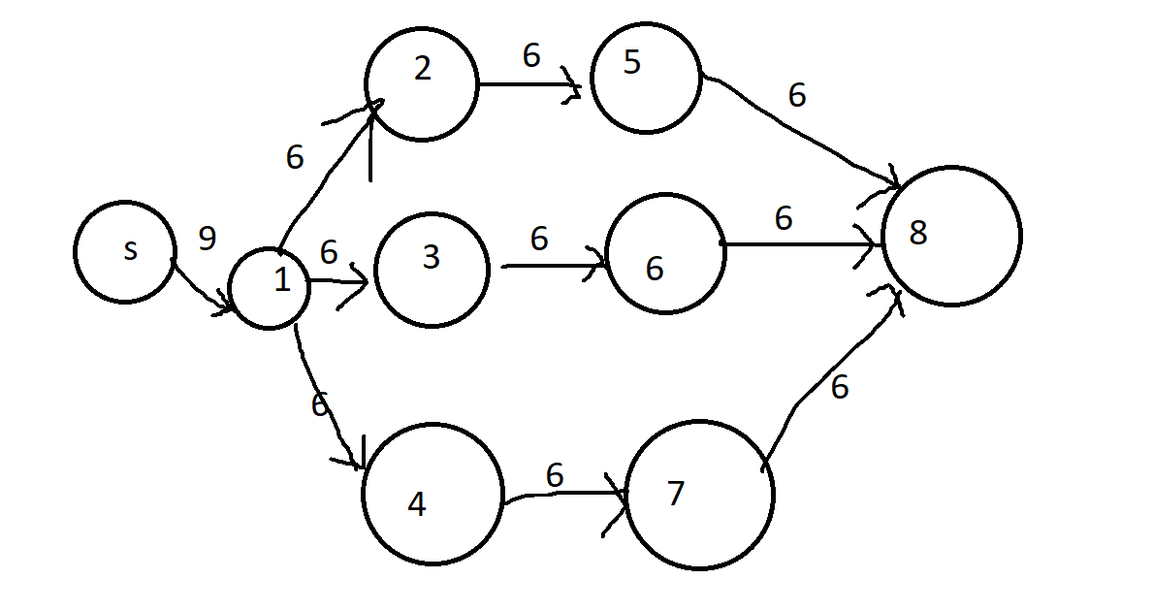

We can easily see that the new minimum cut has changed with $A=\left\{s\right\}$ and $\text{cap}\left(A,B\right)=9$.

